To perform a pipeline project

1.Start Jenkins Dashboard.

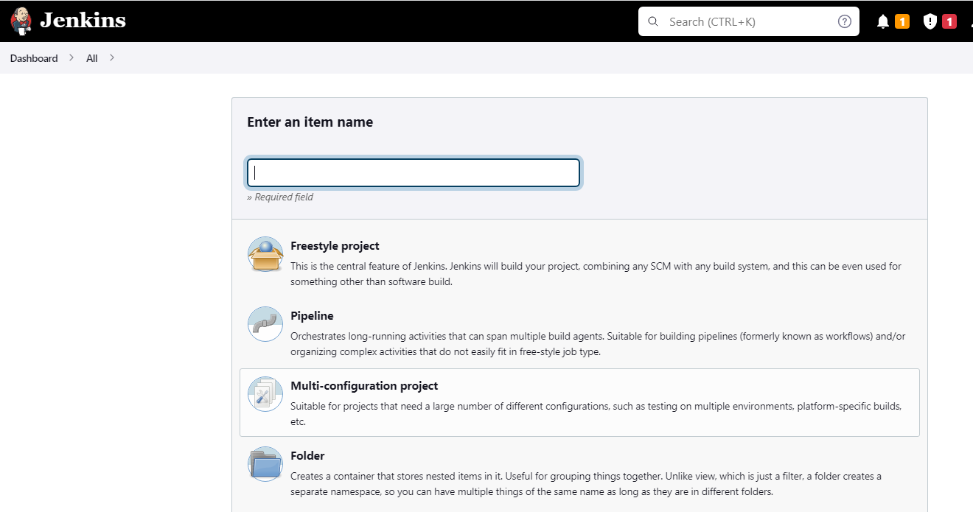

2.Create a new job –Pipeline, give it a name as a mavenBuild



3.Select a git hub repository with Java Code

<https://github.com/Sonal0409/simple-java-maven-app.git>

code: <https://github.com/Sonal0409/simple-java-maven-app.git>

4.Write pipeline code to clone the repository

https://github.com/Sonal0409/simple-java-maven-app.git

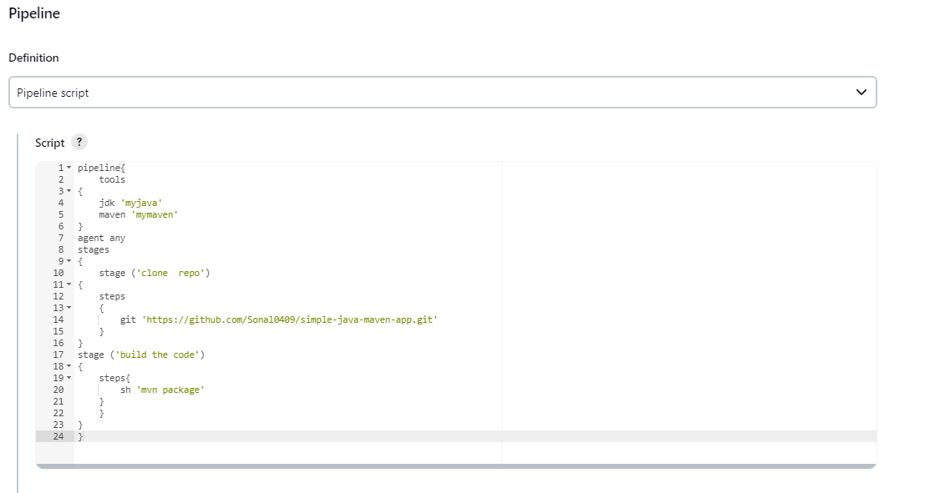

5.Add a stage to package the Job using maven

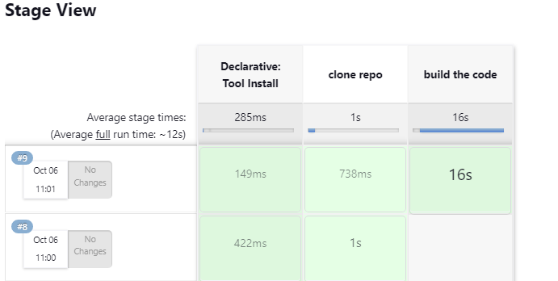

6.Build the pipeline and check all the stages are executed successfully.

